Capital Equipment Inventory Report Instructions

Open the link for the desired report format from the Property Management web page which is located at <http://busfin.colostate.edu/prp.aspx>. Under the Reports heading, the report is available in 2 different formats for your use:

1. Organization Equipment report for Capital Equipment Inventory – this report works best to read the report online or for saving it as a PDF.
2. Organization Equipment report for Capital Equipment Inventory-Excel – this report opens in a table format to save it as an Excel spreadsheet.

\*Note – the same asset information will be displayed no matter which report format you use. This report is fed directly by the Kuali CAM database and reflects current, up to the minute information.

An error may pop up once you select the report that you desire, click ok.

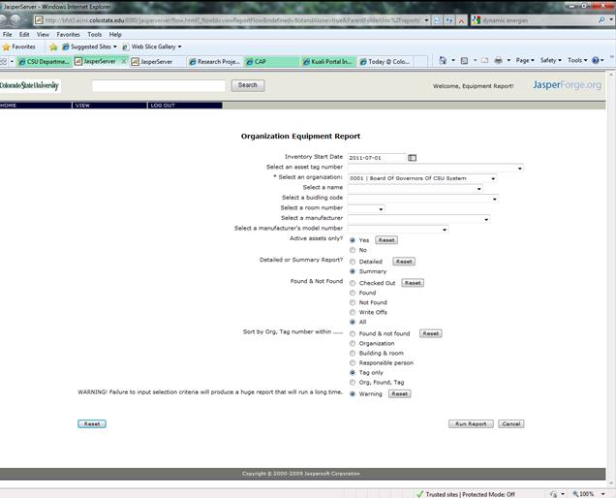

Fields marked with an \* are required fields to run the report.

* The *Inventory Start Date* will default to the beginning date for the current fiscal year and determines Found/Not Found type information for the report. Select a date from the calendar to change this cut-off date, if necessary. (If you are looking for the current fiscal year report then do not change the default date)
* *Select an asset tag number* from the drop-down if you wish to generate a report for a single asset.
* *Select an Organization* has the drop-down to choose which department you wish to query.
* *Select a name* allows you to obtain a report for a specific responsible person.
* *Select a building code* and *Select a room number* to limit the query by location or indicate a single lab.
* *Select a manufacturer* and *model number* fields can be utilized to investigate if certain types of equipment are available elsewhere on campus.

The other selections allow you to further filter and sort your desired report:

* *Active assets only?* If you select No, the report will give you active and retired assets
* *Detailed or Summary Report?* The summary report shows most information and the detailed report lists every journal entry in the record separately (we recommend running the summary report)
* *Found & Not Found* shows data based on the cut-off date selected above (*Write offs* report lists all write offs for department; *All* only shows write offs done after cut-off date)
* *Sort by Org, Tag number within* determines the layout and order of the report (if a report contains multiple departments it will always sort by that first)
  + *Found & Not Found* – list the data by tag number under Checked Out, Found, Not Found and Write off categories.
  + *Organization* – lists the data by department and then tag number
  + *Building & room* – lists data by location
  + *Responsible person* – to group data by person/name
  + *Tag only* is the default format
  + *Org, Found, Tag* – lists the equipment that would meet cutoff date but does not include headers for the categories.

Click on the *Run Report* button:

If you selected Organization Equipment report for Capital Equipment Inventory the following report will be generated:

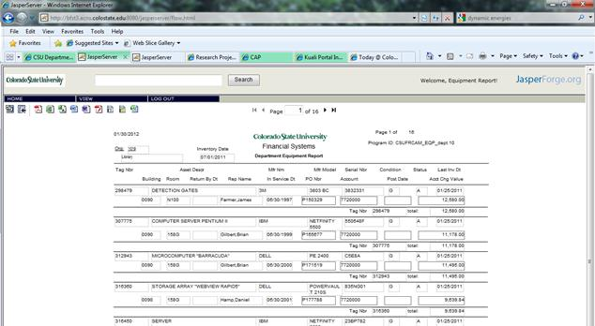

[“Organization Equipment report for Capital Equipment Inventory” Use arrows at top to navigate report or click  to convert to a PDF… (other options are listed here but PDF is what this report was designed for).

](javascript:exportReport('pdf',%20'flow.html/flowFile/CUSFRCAM_EQP_dept_XL.pdf'))

If you selected Organization Equipment report for Capital Equipment Inventory-Excel the following report will be generated:

[“Organization Equipment report for Capital Equipment Inventory-Excel” click  to export the report with an xls file extension… (it does not like to convert directly to the newer versions of Excel nearly as well)](javascript:exportReport('xls',%20'flow.html/flowFile/CUSFRCAM_EQP_dept_XL.xls'))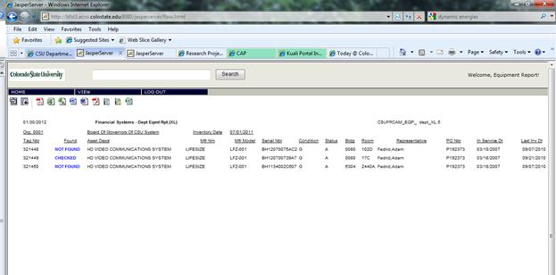

If you would like to run another report after you have already run one, then use the icon at the top of the screen to get you back to the report options:

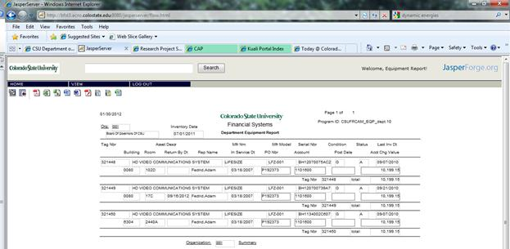

Click double check mark icon to enter new report criteria.

Please contact anyone in Property Management if you have any questions.